# Topic: **Disaster Management and Government Response/Preparedness**

# **Introduction**:

**(Grabber 1)**

For years, Pakistan has suffered record-breaking temperatures, torrential rains, glacial melt, droughts, and floods. Climatologists described Pakistan’s floods in 2010—the most damaging deluge until the current crisis—as “the worst natural disaster to date attributable to climate change.” The scale of the recent deadly flooding in Pakistan is staggering. The financial cost of climate risks has been on the rise for Pakistan. Disaster management can be the organization and management of resources and responsibilities for dealing with all humanitarian aspects of emergencies, in particular preparedness, response and recovery in order to lessen the impact of disaster. Disaster response comprises of these phases: prevention, mitigation, preparedness, response and recovery from the disastrous situation. Hence, though Pakistan seems unprepared to develop an effective disaster management response strategy, given the damages caused by the recent cataclysmic floods due to heavy torrential rains; however, an efficacious disaster management response should include mitigating the damages, rehabilitating a mass exodus, and reconstructing the physical infrastructure destroyed.

Disaster management

The financial cost of climate risks has been on the rise for Pakistan. The existing heavy level of borrowing, weak economic performance and climate vulnerability, all add up to weaker sovereign ratings and higher borrowing rates.

A very high percentage of Pakistan’s present borrowing is often focused on governance and institutional reforms, instead of directly contributing towards economic productivity, accelerated economic growth, or strengthening foreign exchange earning capacity. This borrowing policy is neither desirable nor sustainable.

**(**Grabber 2**)**

The scale of the recent deadly flooding in Pakistan is staggering. Floods triggered by early monsoon rains began in June and have remained intense throughout the season. A full one-third of Pakistan’s territory is underwater—an amount of land that exceeds the total area of the United Kingdom. More than 30 million people, about 15 percent of the population, have been affected. The flooding has killed nearly 1,200 people and left half a million people homeless. However, the full extent of the damage remains unknown, and these numbers may still rise.

**(**Grabber 3**)**

Clearly, Pakistan needs to abandon this suicidal path whereby all our remedial measures for climate-induced disasters add further to the cost of disasters. They are reducing our climate resilience and sustainability. No measures should reduce our social and economic viability. Can the National Economic Council, the apex economic decision-making body chaired by the prime minister, take clear and firm decisions and guide the country on financing climate disasters?

# **Recent Floods – Cataclysmic Disasters (2-3- Paras)**

* A Catastrophe for economy, healthcare, education, infrastructure, human lives and livestock, agriculture,
* Food Insecurity, Water-borne diseases, rehabilitation of a mass exodus, provision of essential commodities. [Post Disaster Plan]

# **Factors Responsible for such a large disaster (3 Paras)**

* South Asian Monsoon
* Changing Climatic Pattern
* Granting permissions for raising construction in waterways.
* Dams.

**(**Optional Content**)**

**What is the South Asian monsoon?**

The Southwest or the Asian Summer Monsoon is essentially a colossal sea breeze that brings South Asia **70-80** percent of its annual rainfall between June and September every year.

It occurs when summer heat warms the landmass of the subcontinent, causing the air to rise and sucking in cooler Indian Ocean winds which then produce enormous volumes of rain.

**Why it is important?**

The monsoon is vital for agriculture and therefore for the livelihoods of millions of farmers and for food security in the poor region of around two billion people.

But it brings destruction every year in landslides and floods. Melting glaciers add to the volume of water while unregulated construction in flood-prone areas exacerbates the damage.

**Is it the same every year?**

Despite being heavily studied, the monsoon is relatively poorly understood. Exactly where and when the rain will fall is hard to forecast and varies considerably.

This year, for example, while Pakistan has seen a deluge, eastern and northeastern India reportedly had the lowest amounts of July rainfall in 122 years.

**What explains the variability?**

Fluctuations are caused by changes in global atmospheric and oceanic conditions, such as the El Nino effect in the Pacific and a phenomenon called the Equatorial Indian Ocean Oscillation (EQUINOO) only discovered in 2002.

Other factors are thought to include local effects such as aerosols, clouds of dust blowing in from the Sahara desert, air pollution and even irrigation by farmers.

**What about climate change?**

India is getting hotter and in recent years has seen more cyclones but scientists are unclear on how exactly a warming planet is affecting the highly complex monsoon.

A study last year by the Potsdam Institute for Climate Impact Research (PIK) tracking monsoon shifts from the mid-20th century suggested that it was becoming stronger and more erratic.

Initially, aerosol pollution reflecting sunlight subdued rainfall, but from the 1980s the warming effects of greenhouse gases began to drive stronger and more volatile rainy seasons, the study said.

Do other studies bear this out?

Broadly yes. The Indian government's first ever climate change assessment, released in 2020, said that overall monsoon precipitation fell around six percent from 1951 to 2015.

# Challenges to Disasters’ Response

* First, while climate change is a federal subject, floods and several other extreme events fall in the provincial sphere of responsibilities.

**(**Optional**)**

Institutional roles and responsibilities are sometimes unclear between local, provincial and federal level entities. The threshold points that specify at what junction federal institutions would get involved in a local or provincial disaster are not clear.

* Second, there are no data sets or clearly designated institutions for various types of climate disasters to bridge the emergency-development continuum.

**(**Optional**)**

All Pakistan has is household income data maintained by the Benazir Income Support Programme. BISP does not have any vulnerability maps nor has it collected data from beneficiary households for disaster vulnerabilities — understandably so because its mandate is limited to income support to people living below the poverty line. Since BISP also does not maintain any information on climate disasters faced by its beneficiaries or on extreme events occurring in its areas of operation, it can only act as a post office and disburse equal or flat amounts without independent damage assessments and verifications. National and provincial disaster management authorities or other departments do not provide any yardstick to determine the level of support needed for each disaster category.

* Third, there are no financing mechanisms in place for disaster management. Contingency and emergency funds are not embedded in federal and provincial budgets.
* Fourth, and most critically, is the absence of a disaster-recovery framework that serves as a building block for reconstruction and resilience.

**(**Optional**)**

Pakistan’s disaster preparedness journey started in 2005 when it committed to the Hyogo Framework for Action. It coincided with that year’s tragic earthquake upcountry. The HFA was a blueprint for Pakistan’s disaster-risk reduction efforts and shaped the policy direction of our newly created institutions. However, Pakistan’s underlying disaster-risk drivers remained strong. Sufficient institutional, legislative and policy frameworks did not exist or were not sufficiently strong to integrate disaster-risk reduction in policy planning.

# Already Measures Taken by Pakistan for Flood-hit

* **2022 Pakistan Floods Response Plan (FRP)** was jointly launched today by Government of Pakistan and the United Nations, simultaneously in Islamabad and Geneva.

**(**Optional**)**

The FRP focuses on the needs of 5.2 million people, with life-saving response activities amounting to US$ 160.3 million covering food security, assistance for agriculture and livestock, shelter and non-food items, nutrition programmes, primary health services, protection, water and sanitation, women’s health, and education support, as well as shelter for displaced people.

* Instrumental role of NGOs as part of communal support in flood-hit areas - Alkhidmat foundation, Women Democratic Front etc.
* The NDMA committed in Sendia Framework for Disaster Risk Reduction (SFDRR) that Pakistan would embark on a seven-year journey of yearly targets from 2016 to 2022.

**(**Optional**)**

The Sendia Framework for Disaster Risk Reduction (SFDRR) target for 2022, for example, is to “increase the availability of and access to multi-hazard early warning systems and disaster-risk information and assessment to people”. It is an ongoing target for 2030 and an extremely important entry point for Pakistan to engage with the global community to support the former’s reconstruction or reparation needs after floods. SFDRR Priority 4 focuses on ‘build-back-better’ (BBB) in the post-disaster recovery, rehabilitation and reconstruction for the restoration of physical infrastructure and societal systems, and to revise livelihoods, economy and environment.

* Climate Diplomacy to attract international aid

**(**Optional**)**

**Australia** pledged to grant $A2 million to the World Food Programme for the Pakistan emergency. The sector is calling for a further $3 million to be spent, and for it to be directed towards NGOs and humanitarian agencies with local partners on the ground.

**World Bank** pledges up to $1.7 b in flood relief

The European Union will provide **$1.8 million** to relief efforts in Balochistan, Khyber Pakhtunkhwa, Punjab, and Sindh provinces. The United Kingdom has announced **$17.3 million** in funding, and other European countries have followed suit, including Germany, which has pledged **$13 million** to Pakistan.

# **Recommendations to improve the Disaster Response**

* Bangladesh’s Case Studies of Efficient Disaster Response in Urban Flooding

**(**Optional**)**

The Government of Bangladesh (GoB) has taken **The Flood Damage Rehabilitation Project** in 1999 which was formulated in response to the Government’s request to the Asian Development Bank (ADB) for rehabilitation assistance following floods of unprecedented nature, extent, and intensity, which inundated 68% of the land in Bangladesh for 11 weeks from 20 July to 30 September 1998. Under this project the Government worked in the transport sector which includes increasing the height of roads and railways, cross-drainage structure as well as in the infrastructure sector similar projects have been undertaken like increasing the height of coastal polders, erosion control programs, etc. The project was completed in December 2002.

### **Rainwater** harvesting

**Bangladesh** Government has built dikes and canals to control the river system.

* Pakistan needs a two-track strategy for accessing international climate finance: First, it must prioritize borrowing that helps reduce the cost of development by reducing climate vulnerabilities. Second, it must augment national and provincial capabilities to directly access climate-specific financing that often includes grants, concessional lending, leveraging and hybrid financing with the private sector.

# **Facts**

* As a Joint UN Environment and Imperial College study pointed out in 2018, the developing countries have paid $40 billion in additional interest payments over the past 10 years on government debt
* And $62bn in higher interest payments across the public and private sectors.
* A recent directory has listed more than three dozen active climate finance windows supporting projects of varying sizes that our South Asian neighbours have routinely availed. Pakistan has not accessed any of them.
* In fact, Pakistan has not even applied for accreditation of the largest and most famous Green Climate Fund or the Adaptation Fund, both set up by UNFCCC.
* Two Pakistani NGOs that secured GCF accreditation for small projects several years ago have not brought home any projects.
* Multilateral development banks have a multibillion portfolio in the country, but Pakistan has not availed their specialised, climate-related financing facilities.
* The Asian Development Bank (ADB) has also created at least five specialized funds on urban resilience, environmental infrastructure and climate finance.
* Several developed countries have, likewise, created their own celebrated bilateral funding windows.
* These include the International Climate Initiative by Germany and the International Climate Finance by the UK.
* The ICF, for example, is a £5.2bn fund covering areas of Pakistan’s core concern — agriculture, energy and resilience.
* France has moved to take a particular interest in solar leadership, in partnership with India. Pakistan has thus far not accessed any of these funds.

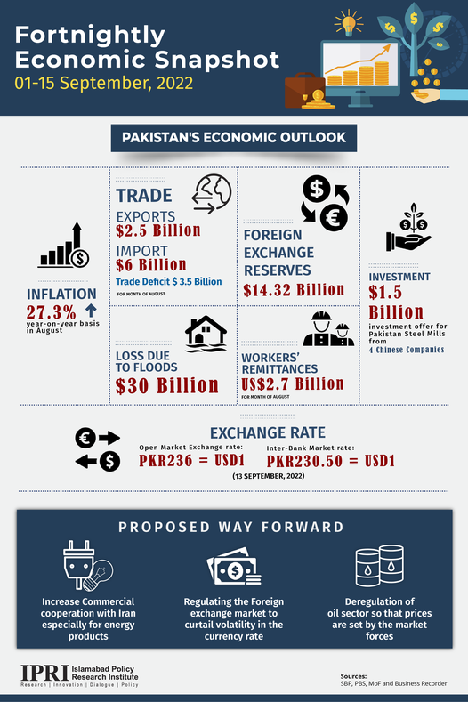 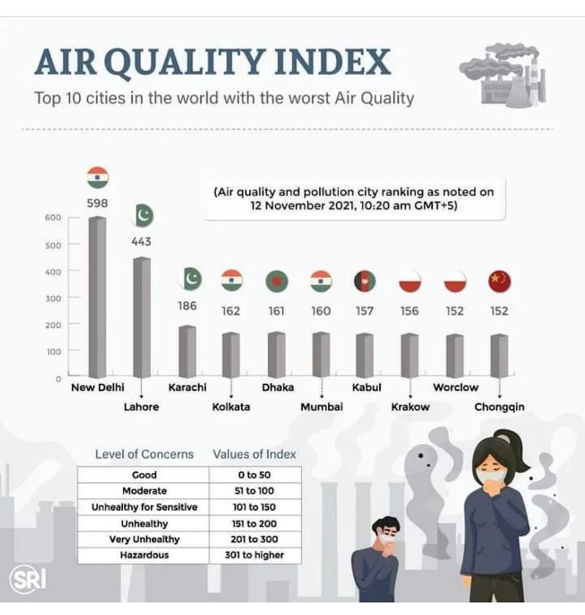

# **References**

1. <https://tribune.com.pk/story/2373748/pakistan-floods-south-asias-monsoon-explained>
2. <https://www.undp.org/pakistan/press-releases/joint-launch-2022-pakistan-floods-response-plan-government-pakistan-and-united-nations>
3. <https://www.preventionweb.net/news/blog-how-reduce-flood-risk-urban-areas-bangladesh>
4. <https://www.dawn.com/news/1709037/reform-relief-resilience>
5. <https://www.dawn.com/news/1713726>
6. E:\academic-repertoire\Dev\English-Essay-Precis-and-Composition\Essay Themes\Urban Flooding Risk Management-Case Studies.pdf